I created below LP

<https://www.platinumcryptoacademy.com/submit-a-press-release/>

I have added below image in LP

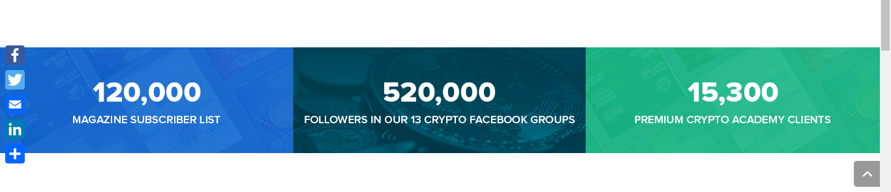

But in mobile view it looks like terrible

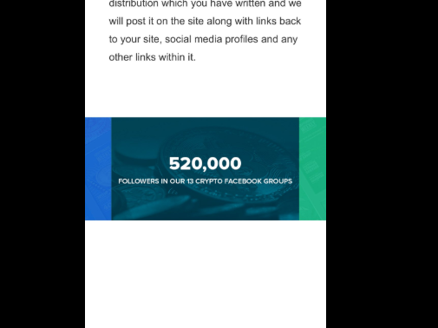

In mobile view image does not appear as full size I want to resolve this issue

I want in mobile view, the above-mentioned image should display as full size